Next, carefully read your classmates’ initial postings and then write a 50 – 80 word response to at least two peers, explaining whether you agree or disagree with their answers and why.
Peer responses are designed to further your understanding of the course content and to help you interact with other students in the course. Critique postings should be thought provoking, specific, carefully written (i.e., free of errors in mechanics, punctuation, and grammar), and must be submitted in a timely manner. No credit will be given for responses such as “I agree,” “Ditto,” or “Nice work.”

Joe Tavary
Without a doubt, Modernism changed architecture, but architecture after Modernism was also influenced by the architecture that preceded, or developed alongside, the International Style and Modernism, such as Constructivism and Futurism. Whereas those previous styles were generally in reaction to historicism, or extrapolating beyond the intellectual framework of that earlier time which was still dealing with historicism, Modernism gave those same radical urges a new host of architectural syntaxes with which to defamiliarize, reorganize, or otherwise interrogate what had been done before, creating a whole new territory for post-modernist designers to explore. Also, over this period of time, priorities shifted as technology like building materials and transportation evolved, allowing new building shapes and purposes that did not exist before. Peter Eisenmann’s House VI (Cornwall, Conn., 1972-5) took some cues from the intersecting planes of De Stijl and Modernism, but its Deconstructivist chops are more aggressive, almost jarring; its premise is not simply a rehashing of what’s been done before, but an investigation of questions that couldn't be framed before Modernism, and that Modernism itself was not equipped to answer.
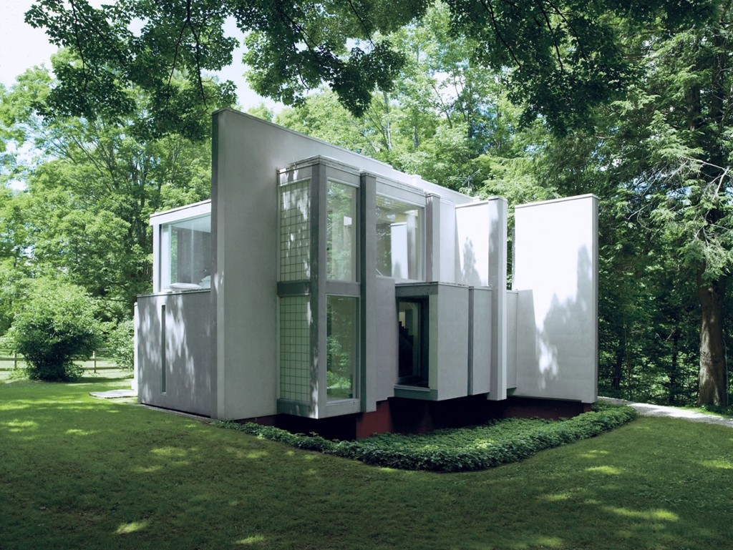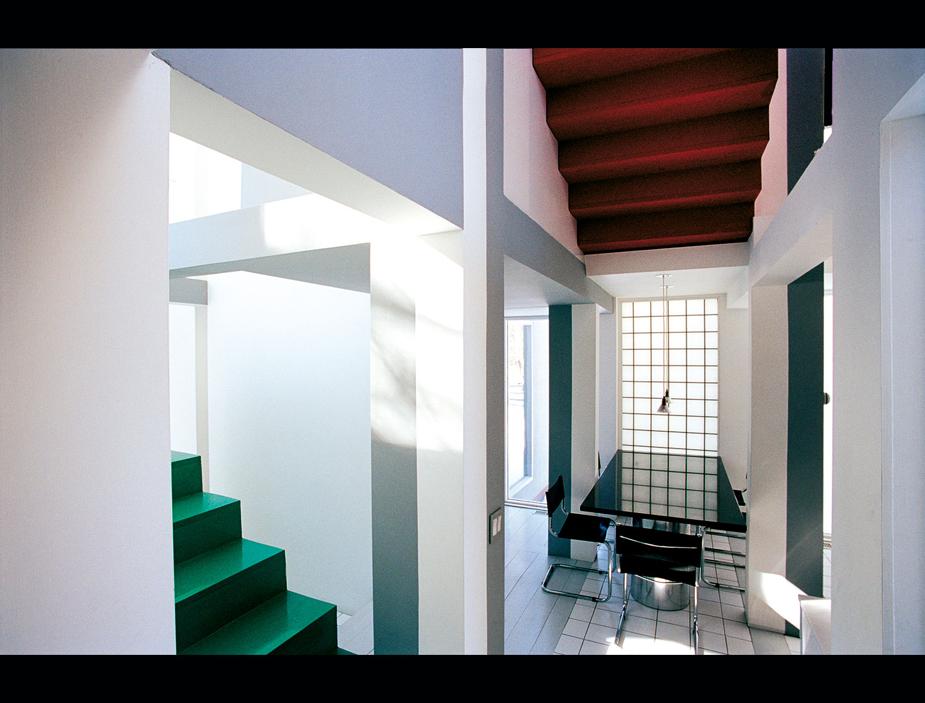

I’d have to say that architecture after Modernism was considerably more liberated than before. Old traditions continued on past Modernism, but in different aspects of themselves. The hunger for new architectural forms and ways of expression that led to Modernism also led past it to Post-Modernism and the other “-isms,” including Deconstructivism, a body of theory that bore little resemblance to anything from before the turn of the century. Some innovations, like thin-shell concrete and geodesic domes, allowed for expressions of structure that did not exist before, providing exploration of new methods and the inception of new traditions. The TWA Flight Center (1962) at JFK International Airport, by Eero Saarinen, was made possible by such technology; it’s symmetrical shell, which looks like it’s about to take flight, would be inconceivable to construct in masonry.
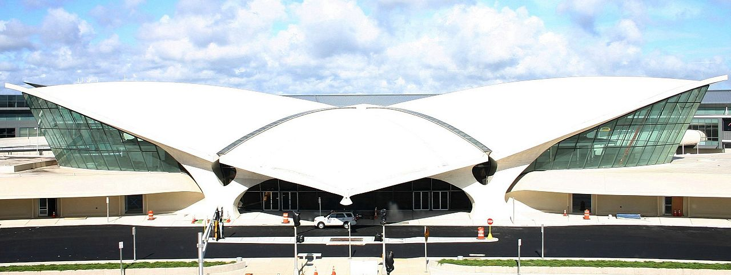

Audra Canestrari
Is the architecture and urbanism of this period different than before the Modernism of the early 20th century? Support your opinion with an example of a building preferably not addressed in the unit reading.
The buildings of the Case Study project were very interesting and a pivotal turning point for architecture. The need for Post World War II housing was a driving force for inspiring the new thoughts of the Modernist architects. They were on a quest to meet a growing need for affordable, yet clean-lined housing. It gave the architects a sense of complete abandonment of traditional architectural elements. They were able to get back to the complete basics of a structure and environmental incorporation. The Case Study House #21 the Bailey House by Pierre Koenig was built for a couple who wanted a small, open design plan and affordability. The home, completed in 1959, was a rare steel-framed Mid-Century Modern residential example. “It is a simple one-story box with a flat roof, built mostly of steel and glass.”⁽¹⁾
The home was built in harmony with the surrounding environment. There were sliding glass doors in the right position for a nice cross breeze and shallow reflective pools for evaporative cooling for the sweltering summer desert heat. Case Study Project #21 is a true merging of indoor/outdoor with the floor-to-ceiling glass that makes up the walls on one side of the home.
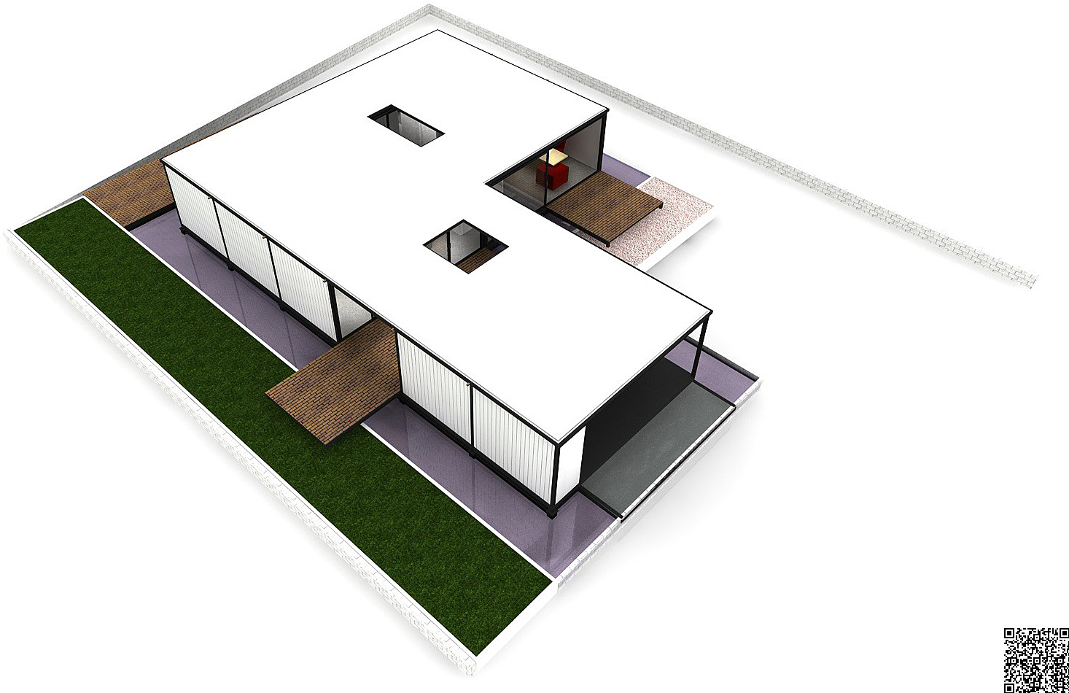
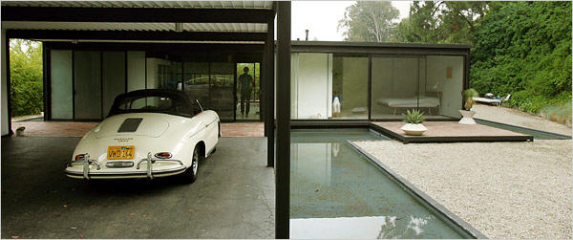
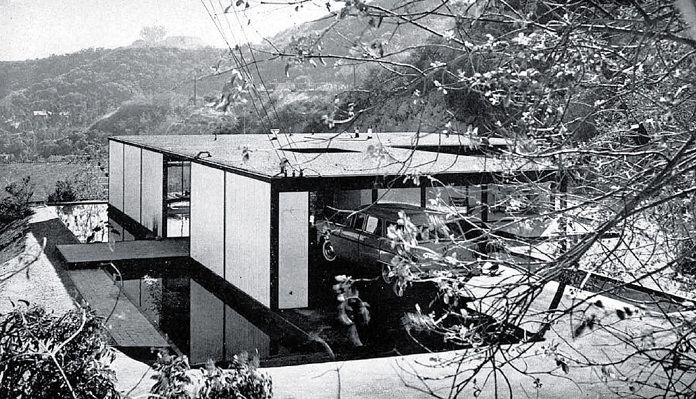
- https://www.laconservancy.org/locations/bailey-house-case-study-house-21

Is there an underlying newness that fundamentally changes in this period, or are older traditions continued? Support your opinion with an example of a building preferably not addressed in the unit reading.
The underlying newness appears to me to be freedom. Freedom and the need to incorporate nature as it exists in the area surrounding the architecture (at least when it came to domestic architecture). There was a newness that met the needs of the patron of the architecture.

